**Online Diary 6:**

**Date:** Tuesday 8th December

**6.0 Character:**

The main character for the game A Woks Journey is John Wok. John Wok is a tall male with short slick black hair and has one blue and one green eye. John is a rude person who seeks power and always want a challenge. He does not care what others think and does things his own way. Fighting is what gives him strength. He is skilled in all form of combat which can be mixed with his demonic magic powers. He acts like a companion with others but gets betrayed

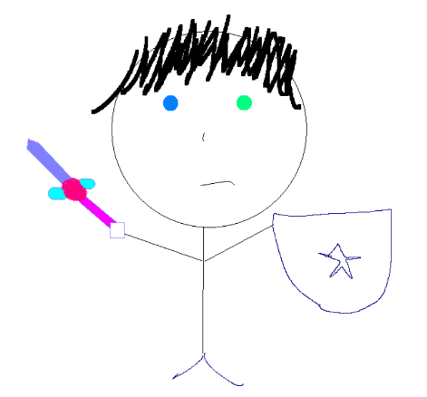

***Figure 1: A drawing of the character “John Wok” with its characteristics***

**6.1 Call to adventure:**

John Wok village gets destroyed by being targeted by bounty hunters. Therefore, John Wok and his best friend Bill Mill must flee. Before fleeing his father had spoken to him about who his real father was and where to find him. This was the last he heard from his father.

**6.2 Supernatural Aid:**

Bill Mill was holding onto a sword that John Wok father gave him, it was a legendary sword that can slice through demons with ease. John Wok was excited and blood hungry

**6.3 Threshold:**

Finds out who his real father is and decides to train him. A girl named Sophie Ash tried many times to get close with John, but he does not take any notice to her as he is focused on power.

**6.4 Abyss:**

As Bill Mill finds out that John Wok and everyone at his fathers’ village had demon blood within them, he betrayed them by killing his dad and stabbing John. Almost dying John demonic blood activates he has no sense to what or who he is.

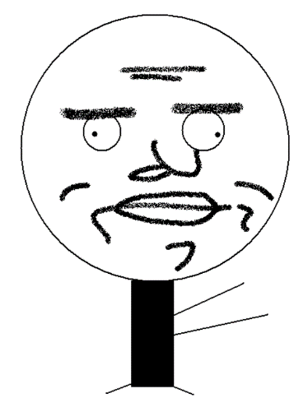  
***Figure 3: Bill Mill the betrayer.***

**6.5 Transformation:**

As John gains consciousness he finds out who he really is, a part of the demon clan and everyone at the village was protecting him. This gave John a whole new meaning to life, he decides to take revenge on everyone that went after him and the village meaning he gave in to the rage and blood lust.

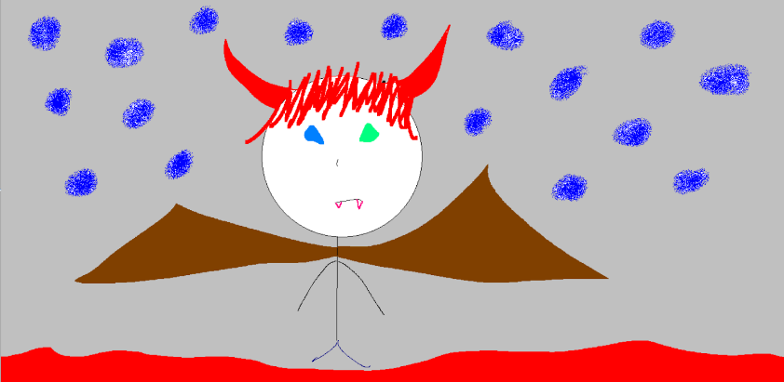

***Figure 4: John Wok after he becomes a demon.***

**6.6 Atonement:**

John Wok ends up finding Bill Mill and they have an epic battle where one of them must die. But defeated by everything he had to go through, he had to go through this last pain before living a good and honest life. He killed his best friend, meaning that this journey has ended.

**6.7 Return:**

After the slaughter of his best friend and the bounty hunters, John Wok goes back to his dads village to confess his love to Sophie Ash, they then return to the village where John was raised and begin to rebuild the village and build a family together.



***Figure 5: The soon-to-be-wife of John Wok***